

MACQUARIE UNIVERSITY

**Faculty of Science and Engineering**

**Department of Computing**

**ISYS224/ITEC624 Database Systems 2019 (Semester 2)**

**Assignment 2 (Report)**

**Database Programming and Implementation (worth 15%)**

**Student Name: Matthew De Masi**

**Student Number: 45585342**

**Student Declaration:**

*I declare that the work reported here is my own. Any help received, from any person, through discussion or other means, has been acknowledged in the last section of this report.*



Student Signature:

Student Name and Date: Matthew De Masi 23/10/2019

1. **Initial State of the database**

**Salary Table**

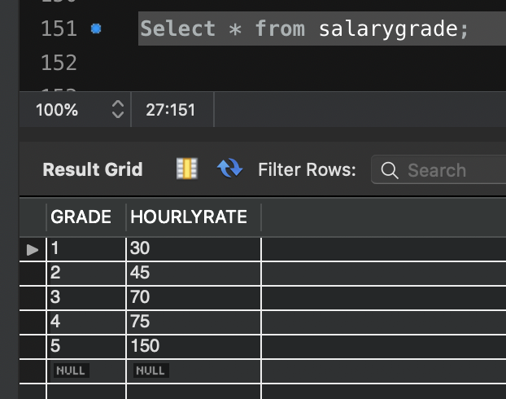

**Staffongrade Table**

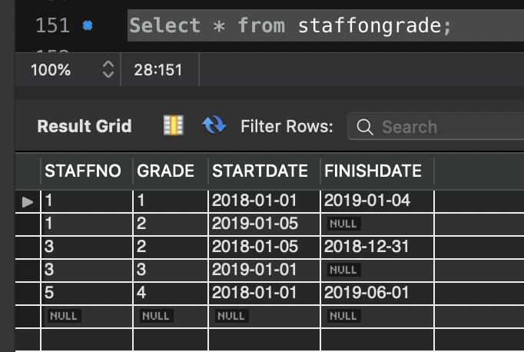

**Salary Table**

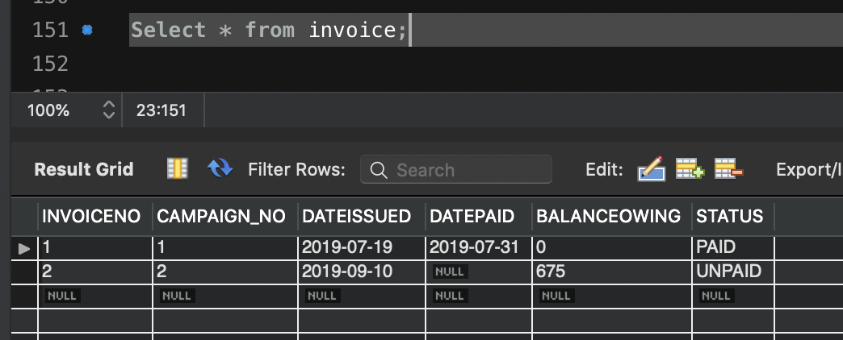

**Workson Table**

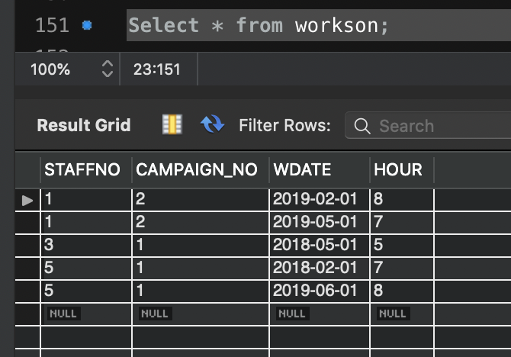

**Staff Table**

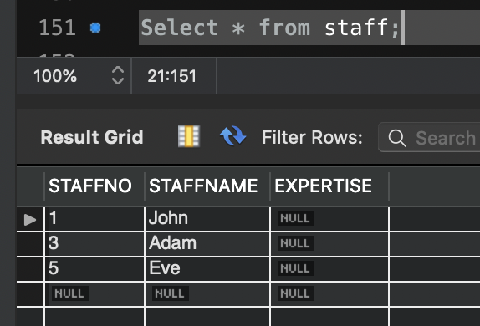

**Salary Table**

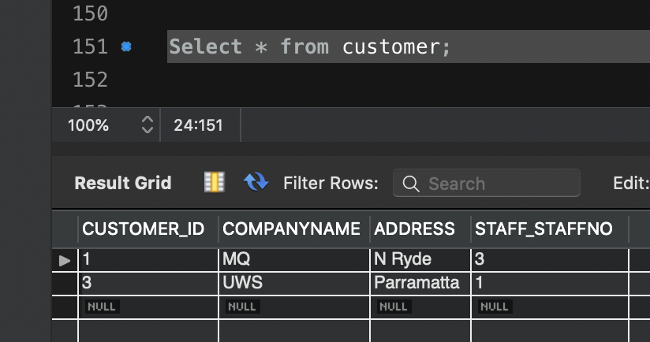

**Campaign Table**

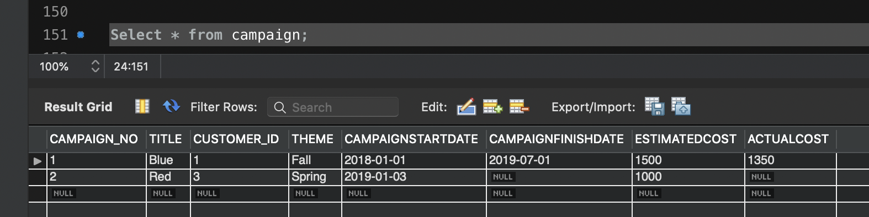

1. **Stored Programs.**

**Trigger Overdue**

delimiter //

drop trigger if exists tr_overdue

//

create trigger tr_overdue

-- type of trigger, etc

AFTER UPDATE ON invoice

FOR EACH ROW

begin

-- implementation goes here

IF NEW.status = 'OVERDUE' THEN

INSERT INTO

alerts (message_no,message_date,orign,message)

values (current_date(), current_user(),CONCAT('Invoice with number: ', OLD.INVOICENO ,'is now overdue!'));

END IF;

end

//

**Rate on date procedure**

drop function if exists rate_on_date //

create function rate_on_date(staff_id int, given_date DATE) returns float

DETERMINISTIC

begin

declare hour_rate float;

declare start_date date;

declare finish_date date;

declare hourly_rate int default 0;

declare v_finished int default 0;

declare hourly_work CURSOR FOR

select hourlyrate, startdate, finishdate

from salarygrade join staffongrade on staffongrade.grade = salarygrade.grade

where staffongrade.staffno = staff_id;

declare continue handler for not found set v_finished = 1;

open hourly_work;

repeat fetch hourly_work into hourly_rate, start_date, finish_date;

if(given_date between start_date and finish_date)

then set hour_rate = hourly_rate;

elseif given_date >= start_date and finish_date is null

then set hour_rate = hourly_rate;

end if;

until v_finished

end repeat;

close hourly_work;

return hour_rate;

end //

**Cost of Campaign procedure**

drop function if exists cost_of_campaign //

create function cost_of_campaign (camp_id int) returns float

DETERMINISTIC

begin

declare total_cost float;

select sum(rate_on_date(STAFFNO,WDATE)*hour)

into total_cost from workson

where camp_id = CAMPAIGN_NO;

return total_cost;

end //

**Sp Finish Campaign procedure**

drop procedure if exists sp_finish_campaign //

create procedure sp_finish_campaign (in c_title varchar(30))

begin

declare B varchar(30);

select count(c_title) into B

from campaign where c_title = TITLE;

if (B != 1) then signal sqlstate '45000'

set message_text = 'ERROR! Campaign title does not exist!';

end if;

update campaign

set ACTUALCOST = cost_of_campaign (CAMPAIGN_NO)

where c_title = TITLE;

update campaign

set CAMPAIGNFINISHDATE = current_date() where c_title = TITLE;

end //

Delimiter ;

**Sync Invoice Table**

drop procedure if exists sync_invoice //

CREATE procedure sync_invoice()

begin

declare dDate date;

declare stat varchar(20);

declare d_finished int default 0;

declare d_array cursor for select DATEISSUED, STATUS from invoice;

declare continue handler for not found set d_finished = 1;

open d_array;

repeat

fetch d_array into dDate, stat;

if (datediff(current_date(), dDate)> 30 )then

Update invoice Set STATUS = 'OVERDUE' Where datediff(current_date(), DATEISSUED) > 30 And STATUS = 'UNPAID';

end if;

until d_finished

end repeat;

close d_array;

end

//

delimiter ;

1. **Required Testing against Sample Database.**

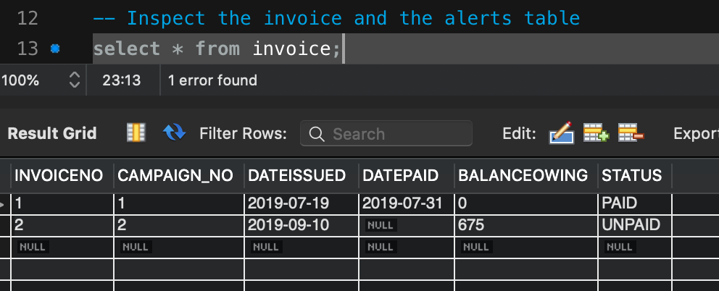

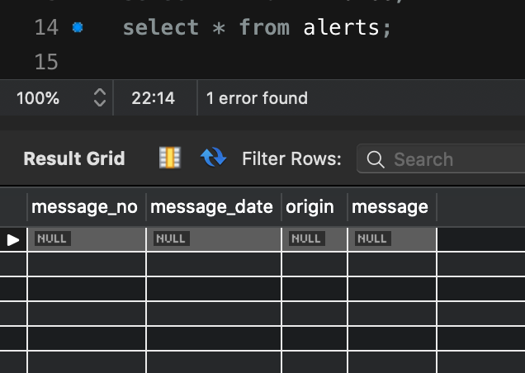

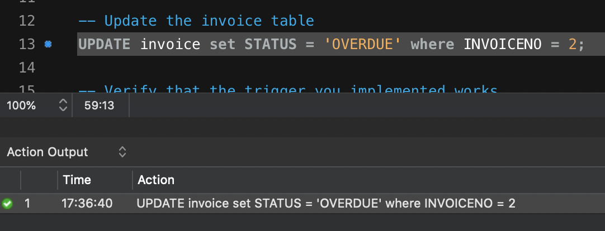

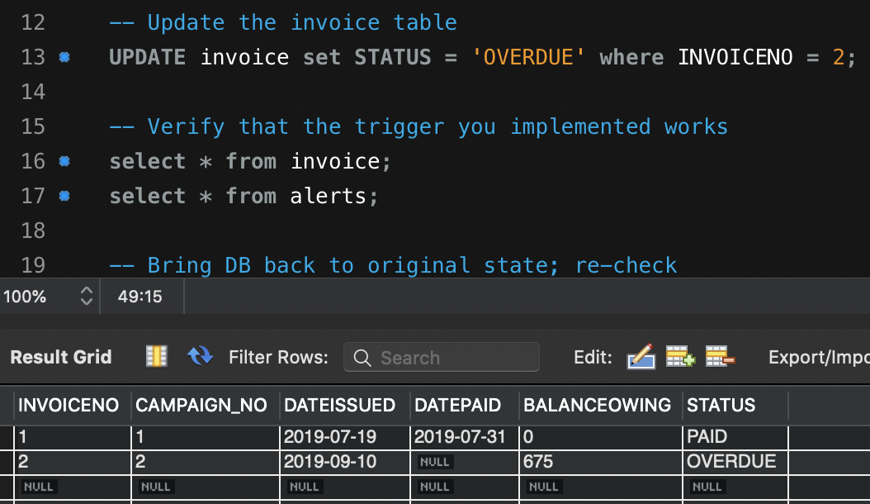

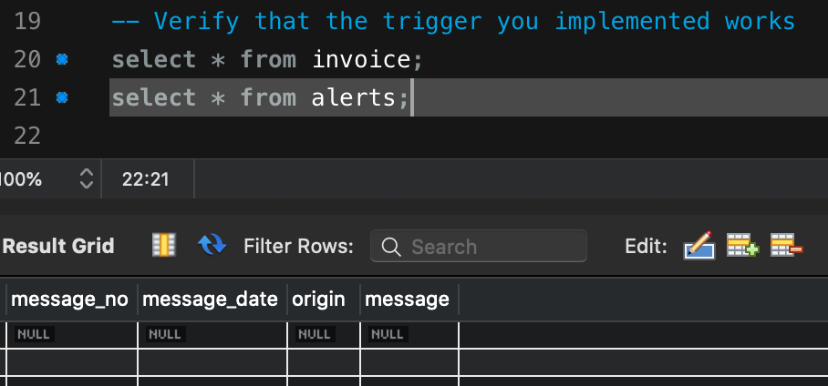

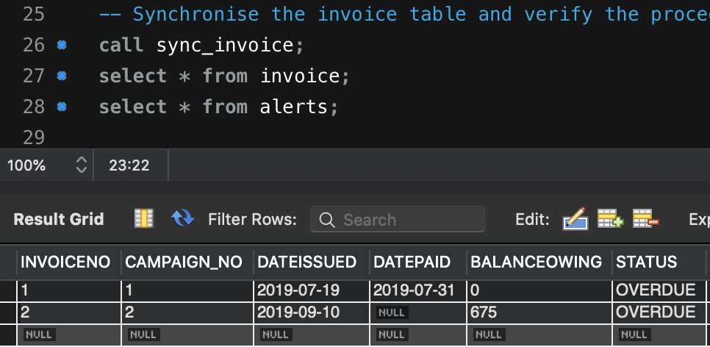

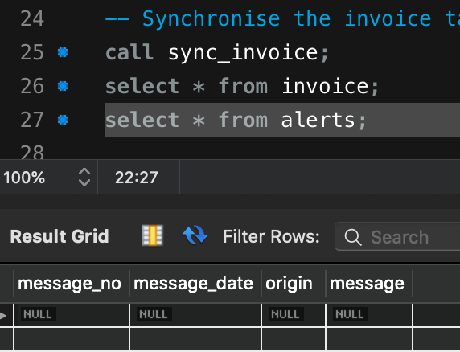

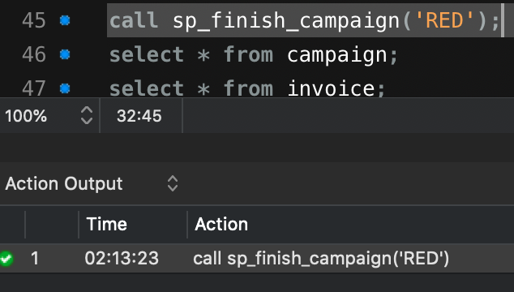

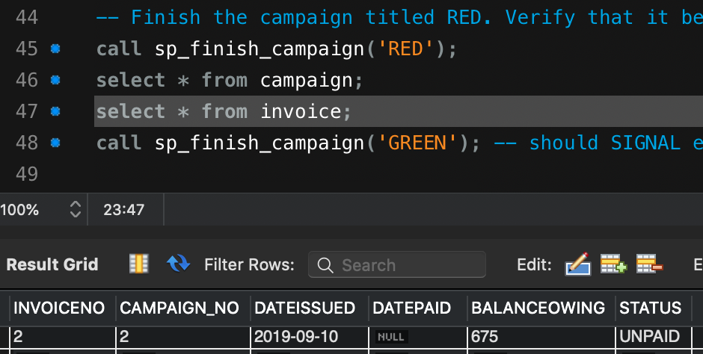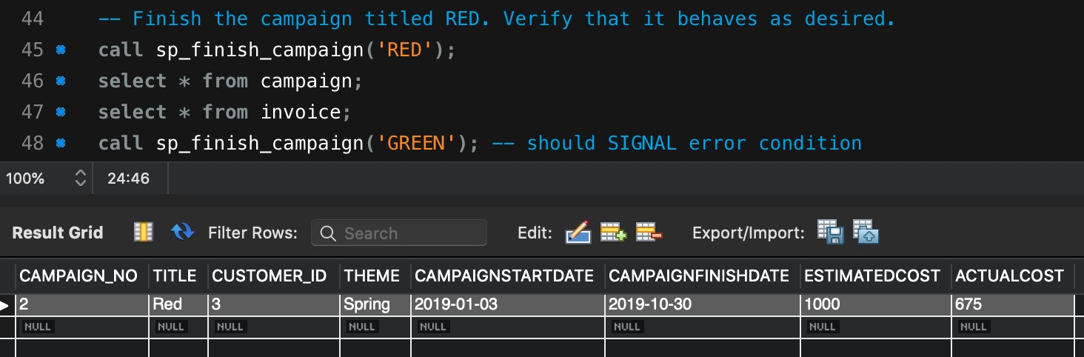

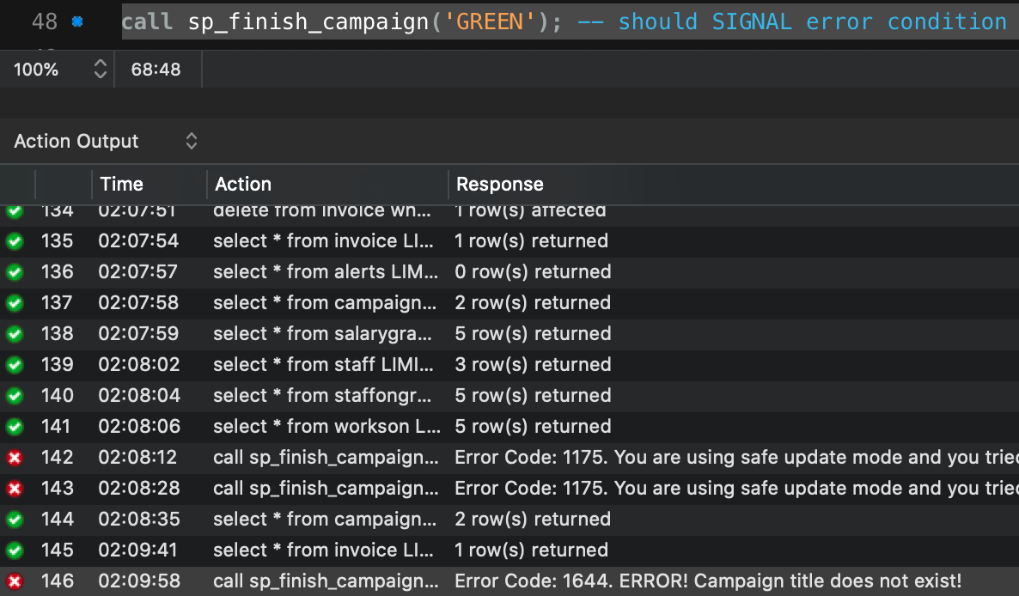

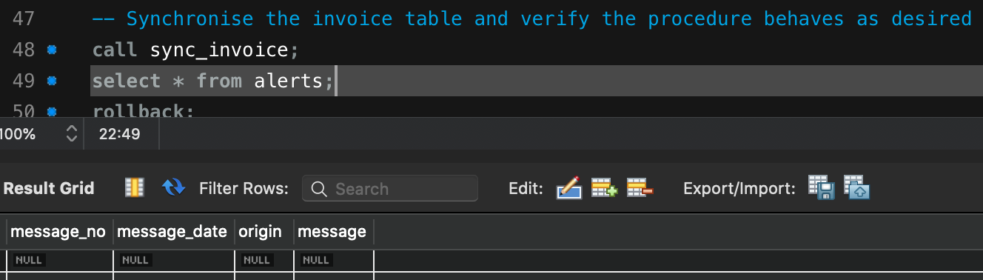

1. **More Extensive Testing.**

**Additional Records applied**



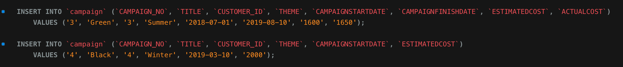

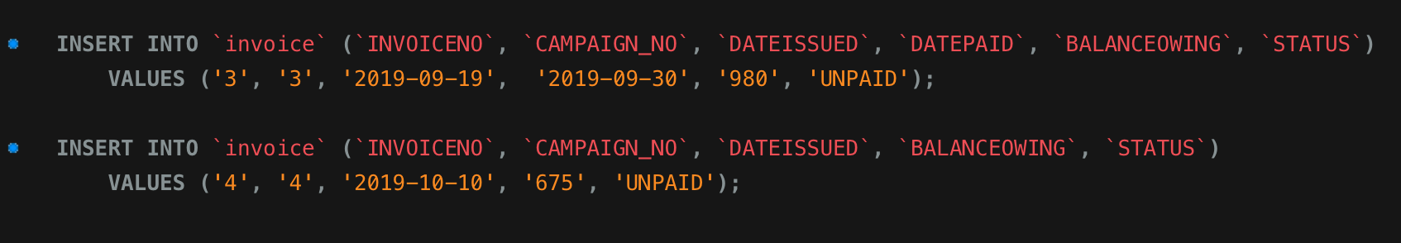

**Testing the additional records**

